Installation notes for OCC Distributori

In IIS manager create an application pool:

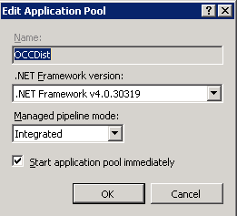

Under a Web Site (e.g. Default Web Site) create an application:

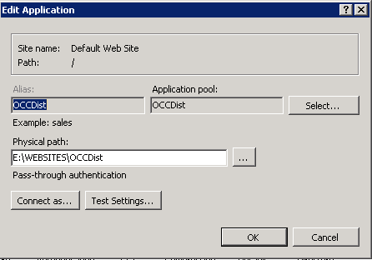

Assign the pool created before and the physical path where the application has been extracted.

To connect the DB modify the string in the web.config file:

*metadata=res://*/OCCModel.csdl|res://*/OCCModel.ssdl|res://*/OCCModel.msl;provider=System.Data.SqlClient;provider connection string="data source=ESMADT19029DAT;initial catalog=OCC;persist security info=True;user id=OCC_Web;password=XXXXXXXXXXXX;multipleactiveresultsets=True;application name=EntityFramework"*

Test environment data source = esmadt19029dat.ww002.siemens.net

Production environment data source = esmadt19085.web.ww002.siemens.net

The password will be sent in a separate encrypted email.